Requirements Analysis Document

Application: <Application name>

Date: <Date>

Index

1. Introduction 3
1.1 Purpose of the system 3
1.2 Scope of the system 3
1.3 Objectives and success criteria of the project 3
1.4 Definitions, Acronyms, and abbreviations 3
2. System Description 4
2.1 Functional Requirements 4
2.2 Non-functional Requirements 4
3. Use Cases 5
3.1 Use Case diagram 5
3.2 Use case descriptions 5
3.2.1 Use Case <name> 5
4. Mockups 6

1. Introduction

1.1 Purpose of the system
Everyone needs somewhere to live or to stay during holidays, and some people have extra houses from which they could get some money. The aim of this system is to relate hosts and guests in order to make easier the process of finding a place to live or stay.
We need a cross-platform application that allow users both to rent out and to hire houses for holidays or for living.

1.2 Scope of the system
The system must be able to let users search using different information, put on sale their offers and buy and reserve those offers.

1.3 Objectives and success criteria of the project
In order to work successfully, the system must have three kinds of users with different functionalities:
- An administrator which approves or denies the offers, so that we can be sure that everything is in order.
- The general, non-registered users, who can just search for offers based on the ZIP code, on a range of type and on the offer type. However, this users are not able to buy or reserve any kind of offer, they can’t even see comments or ratings on the offers.
- Registered users, who extends non-registered users and can be:
- Hosts, who can create and sell offers.
- Guests, who, in addition to search using search using rating, and search reserved and bought offers, can also buy, reserve and rate offers.

1.4 Definitions, Acronyms, and abbreviations
Offer - A house for rent with a set of charateristics that describes it and a price. There are holidays offers, with start and end date, and living offers, which have just start date and can be rented for multiple months.

Guest - A registered user who can just search, rate, buy or reserve offers, but cannot create them.

Host - A registered user who can create offers and rent houses.

2. System Description

2.1 Functional Requirements
There are three different kind of users, administrator, registered and non-registered, and these registered users can have two roles, host and guest (including both at the same time).

2.1.1 User
FR1 . Search using ZIP Code, a range of time, and the offer type.

2.1.2 Registered user
They can be guest, host or both.

FR2 . Login

2.1.2.1 Guest
FR3 . Make an offer reservation.
FR4 . Buy an offer.
FR5 . Search using a minimum comment rating.
FR6 . Search reserved and bought offers.
FR7 . See the available offers.
FR8 . See offer comments and marks.
FR9 . Comment an offer.
FR10 . Rate an offer.
FR11 . See his reserved/bought offers.

2.1.1.2 Host
FR12 . Make offers of a house.
FR13 . Cancel an offer.
FR14 . Modify an offer.
FR15 . See all his offers.

2.1.3 Administrator
FR.16 . Modify user credit card.
FR.17 . Approve offer.
FR.18 . Ask for changes on an offer.
FR.19 . Deny an offer.
FR.20 . Unblock user.
FR.21 . See the non-approved offers.

2.2 Non-functional Requirements
2.2.1 Implementation
As the response time is not important in this case, we will use Java so that the application can work properly on multiple platforms such as Windows, Mac and Linux, and so we will save time and money.

2.2.2 Usability
The user will interact with the system using a Graphic Interface and a mouse, with no keyboard commands, so that the UX is easier and intuitive.
This Graphic Interface is explained later in section 4.

2.2.3 Privacy and Security
All the user information, specially the password and credit card, must be securely encrypted.

2.2.4 Reliability
The application should store all the errors in a log file so that we can fix them as fast and easy as possible, showing friendly and simple messages to the user.

2.2.5 Performance
The application should be able to display dozens of search results without a problem and with an smooth Graphic Interface so that the user has the best possible experience.

2.2.5 Testability
We use JUnit in order to properly test the application.

2.2.7 Documentation
All the code will be properly documented using javadoc, so that every programmer can easily understand it, and the application can be improved and updated with little effort.

3. Use Cases

3.1 Use Case diagram
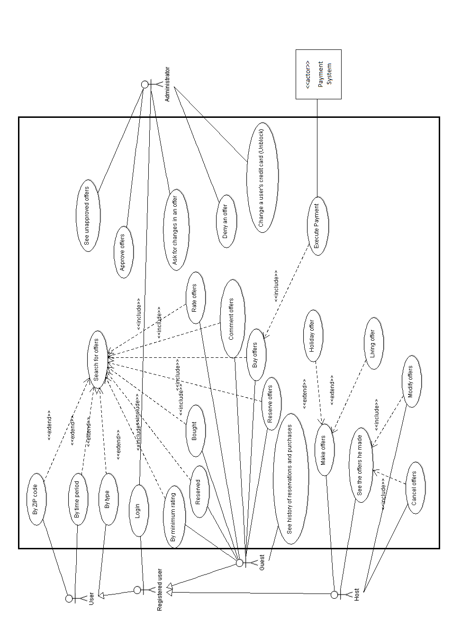

3.2 Use case descriptions
Write a minimum of 3 detailed use cases, using the following template:

3.2.1 Use Case <name>
Primary Actor : <List of primary actors>
Stakeholders and Goals:
<List of Stakeholders and objectives>
Preconditions:
<Explains the state that the system must be in for the use case to be able to start>
Success guarantee (Post-conditions):
<List of conditions that will be true when the use cases ends successfully>
Main Success Scenario:
<List of steps that describe how the use case goal can be achieved and all related stakeholder interests can be satisfied>
Extensions (Alternative paths):
< Alternate and Exception Scenarios >
Special Requirements:
<List of non-functional requirements>
Technology and Data Variations List:
<List of different technological options for functionality in use>
Frequency:
<Estimated frequency of occurrence>
Open Issues:
<Open issues or issues not solved yet, to consider in a future application version >

4. Mockups
4.1 Main screen for non-registered users.
Here you can see the main screen with the two types of searches.
Once they login on the left panel, they go to 4.3 if they are guests, to 4.7 if they are hosts, or to 4.8 if the user is the administrator. Once they search, they go to 4.2.
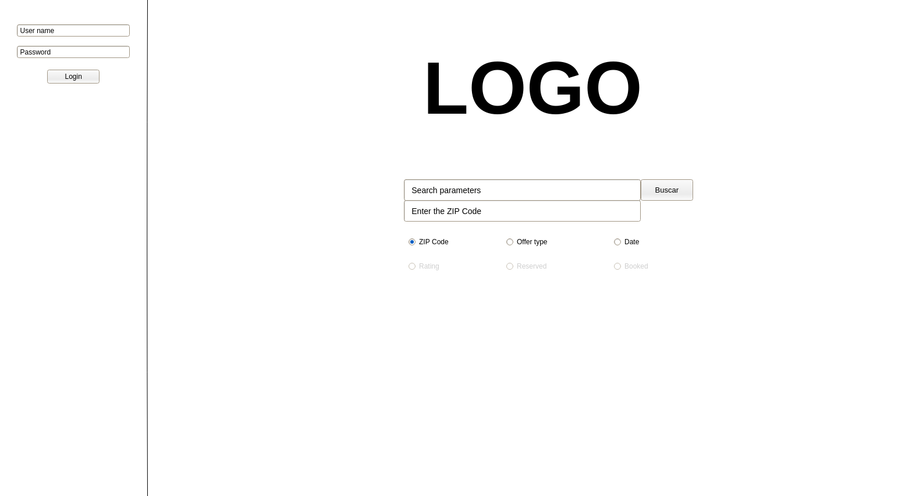
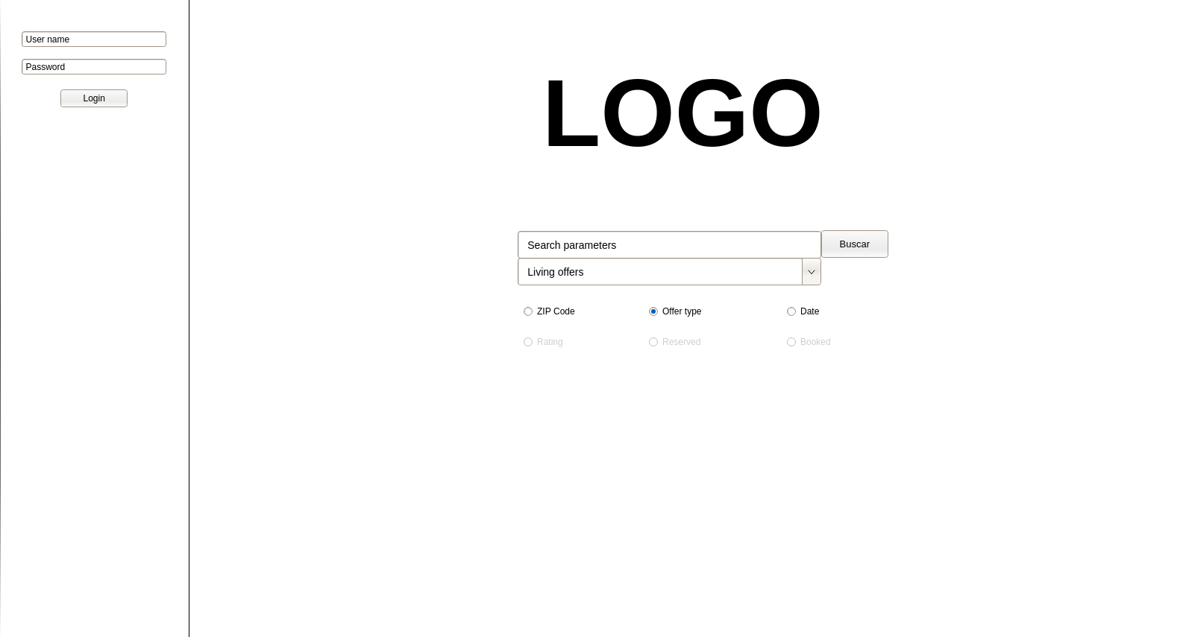

4.2 Search screen for non-registered users.
Once a non-registered user gets to this screen, they can’t do anything but login.
If the user login, he is redirected to 4.4.
Note that the price or the information about the offer availability is not shown.

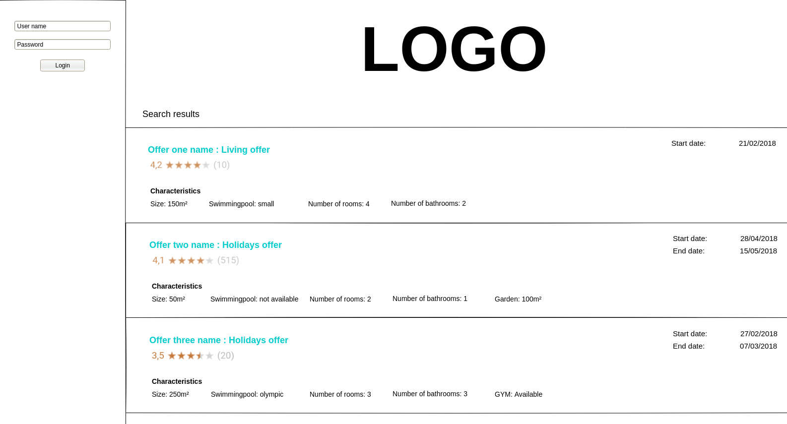
4.3 Main screen for registered users.
Once the user login, he can use more types of searches as the ones shown here as a example.
Note that there is a history button on the left panel that redirects the guest to 4.5.
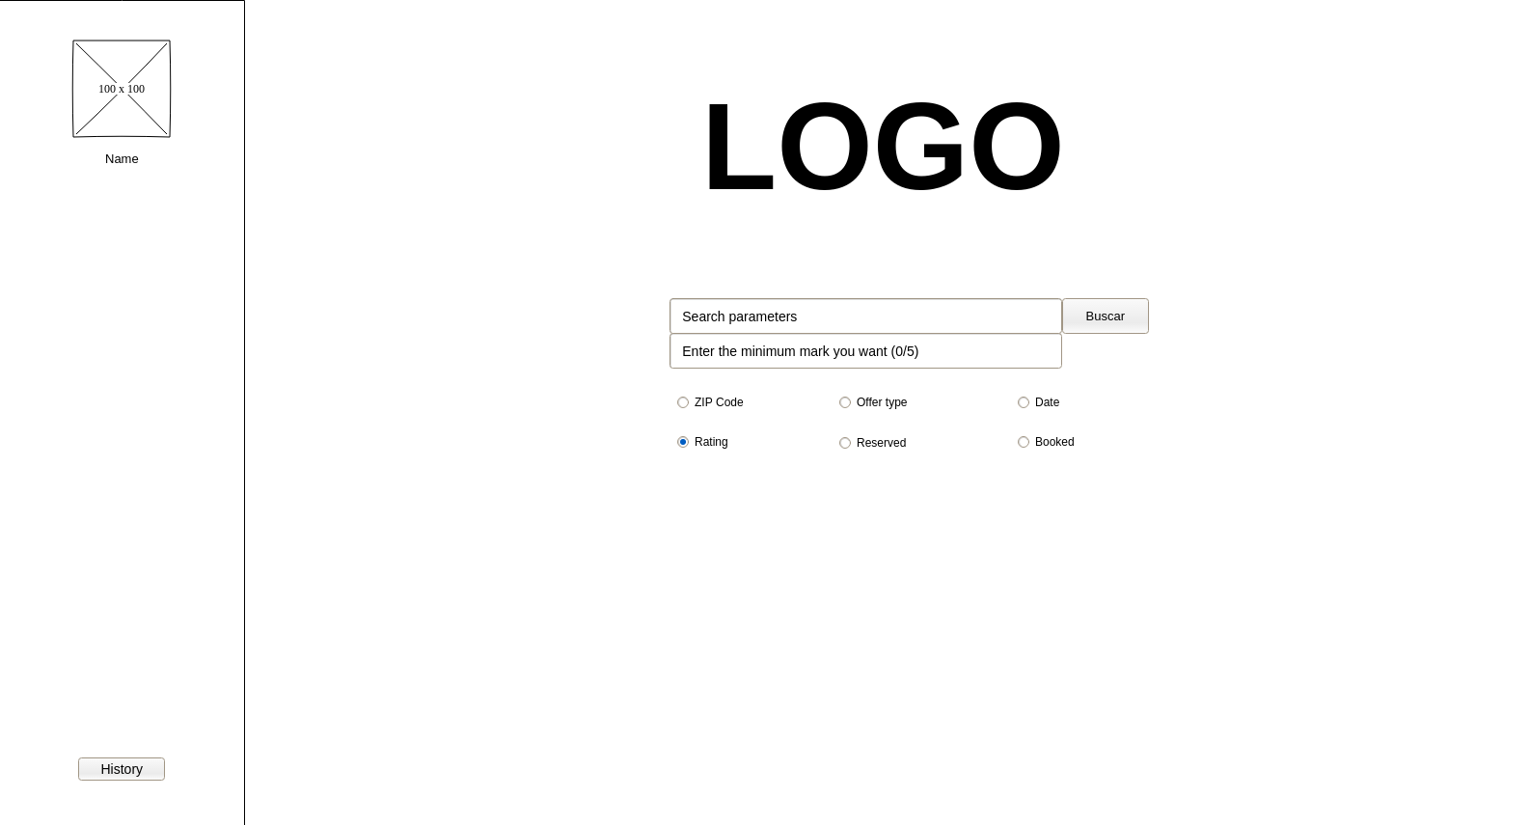

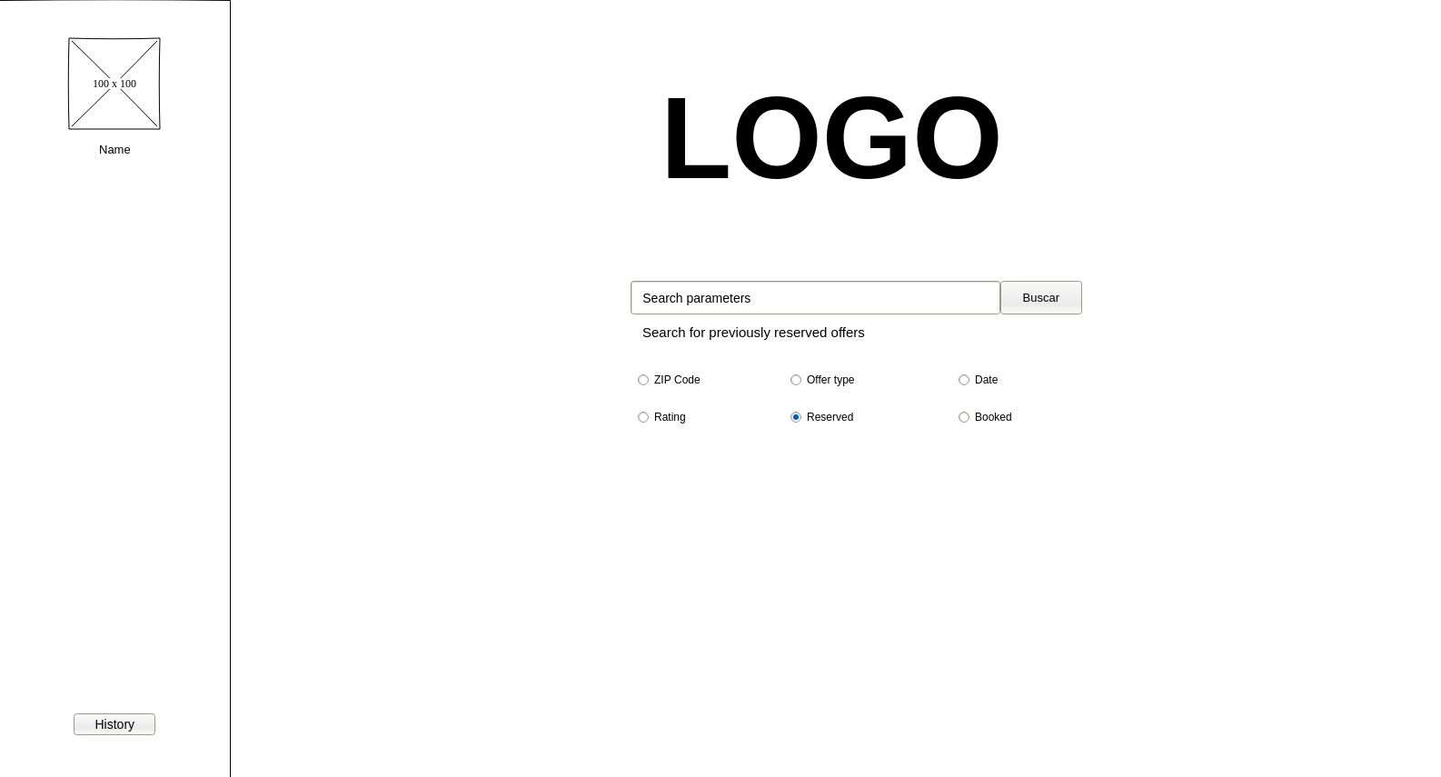
4.4 Search screen for registered users.
Once a registered user search something, he gets to this screen.
If he clicks in any of the offers, he is redirected to a screen like the one on 4.6.
Note that the price and the information about the offer availability is now shown.
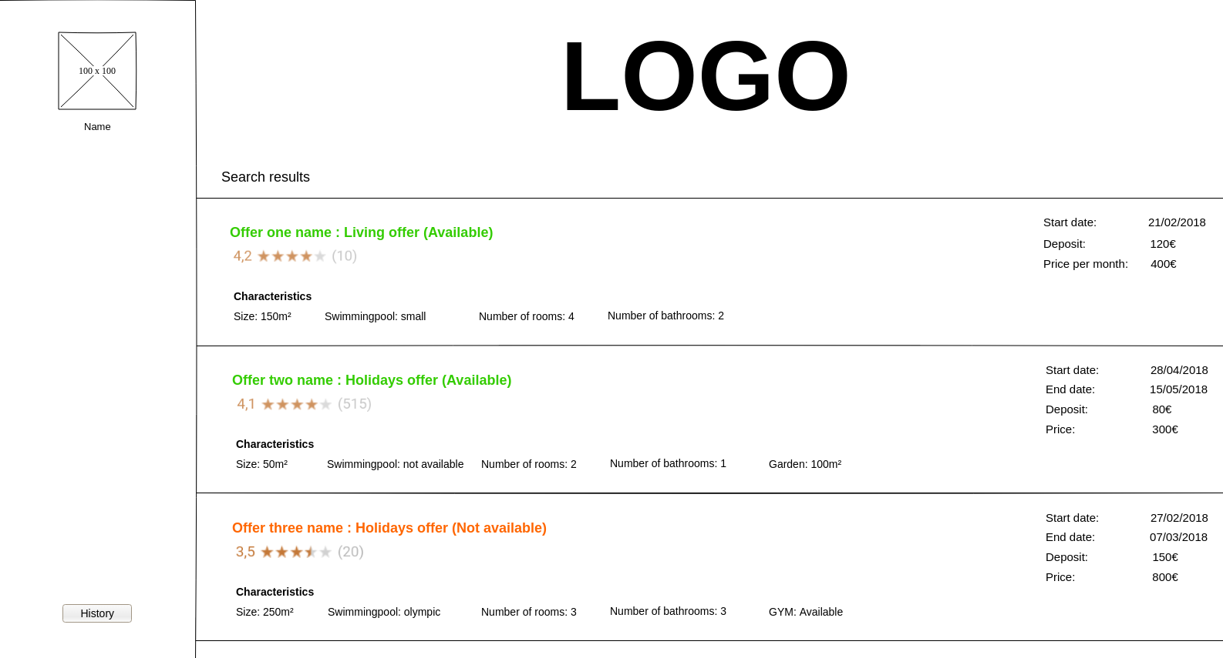

4.5 Guest history.
Once the guest clicks the history button on the left panel, he gets here, where he can see all his bought and reserved offers.
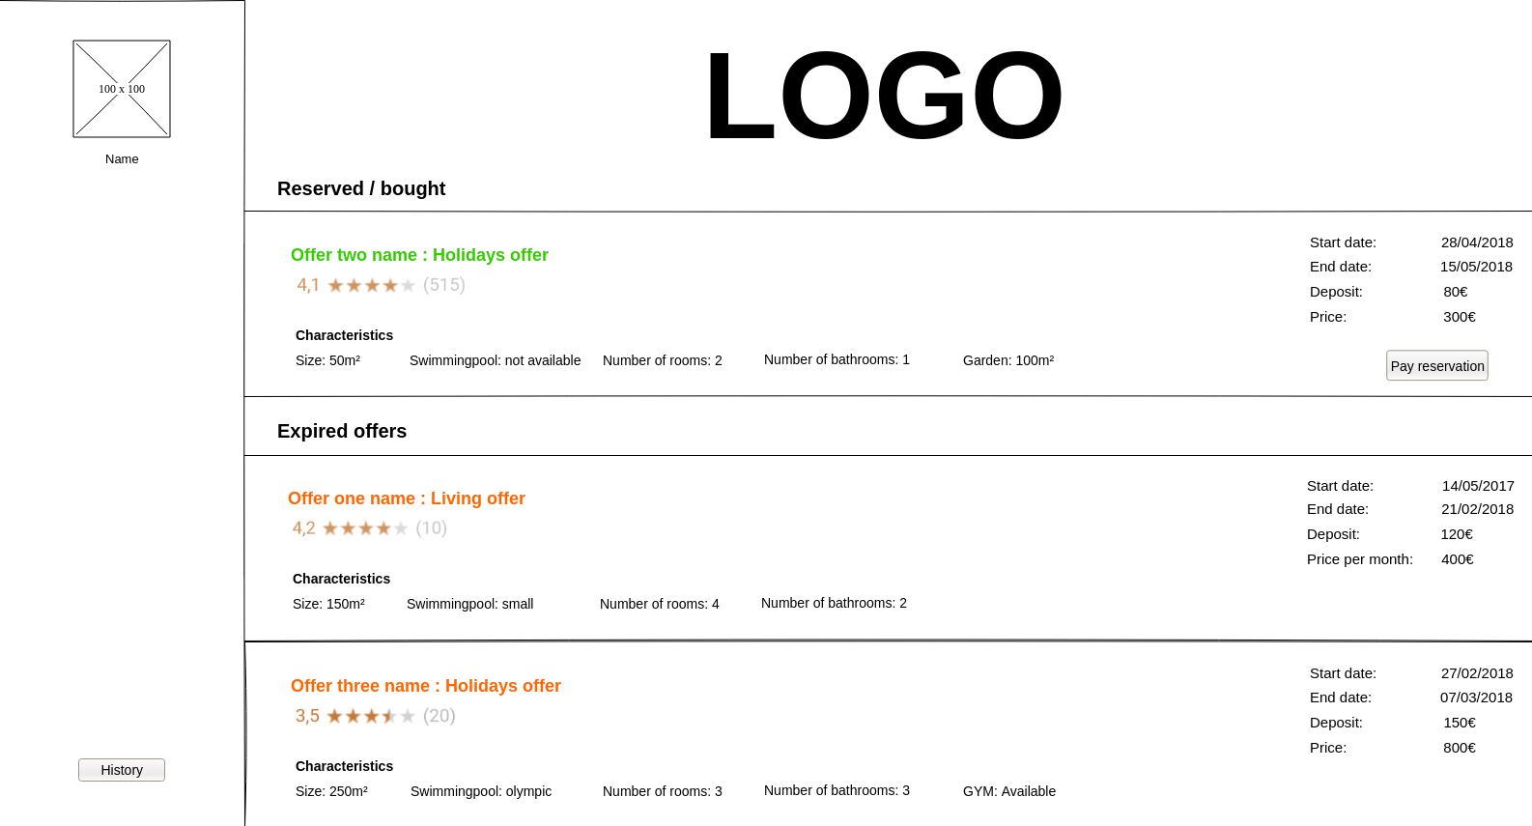
4.6 Offer preview
Here the guest can see all the information and comments on an offer. He can also rate the offer himself.
Once he clicks Comment/Rate button he goes to MAKE THE SCREEN.
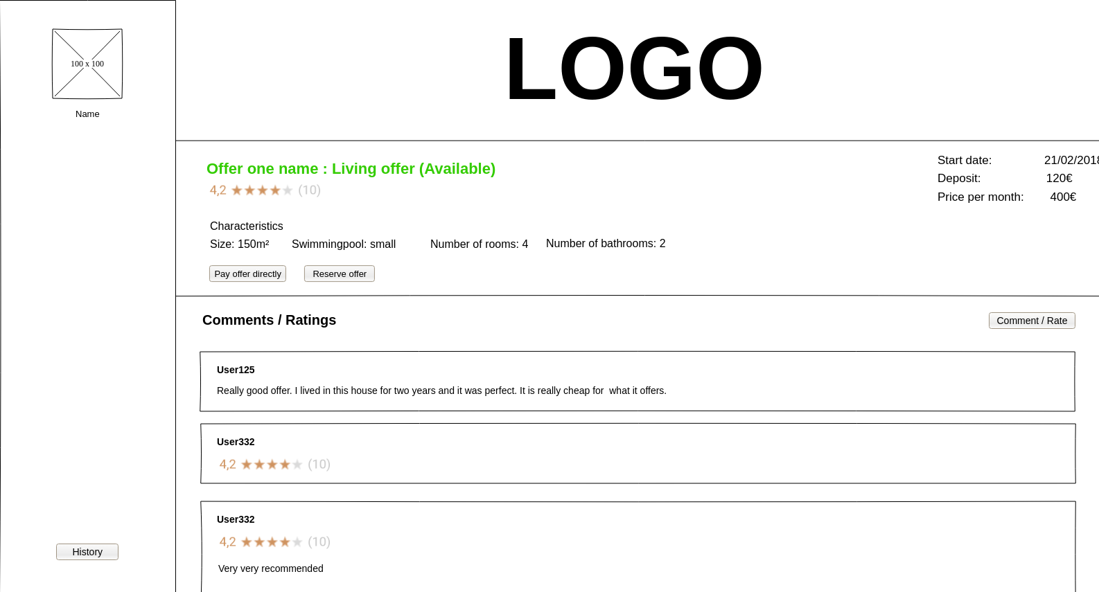

4.7 Host control panel
Here the host can see all his approved or not approved current and previous offers, and the changes he needs to do.
CAMBIAR EXPIRED A PREVIOUS.
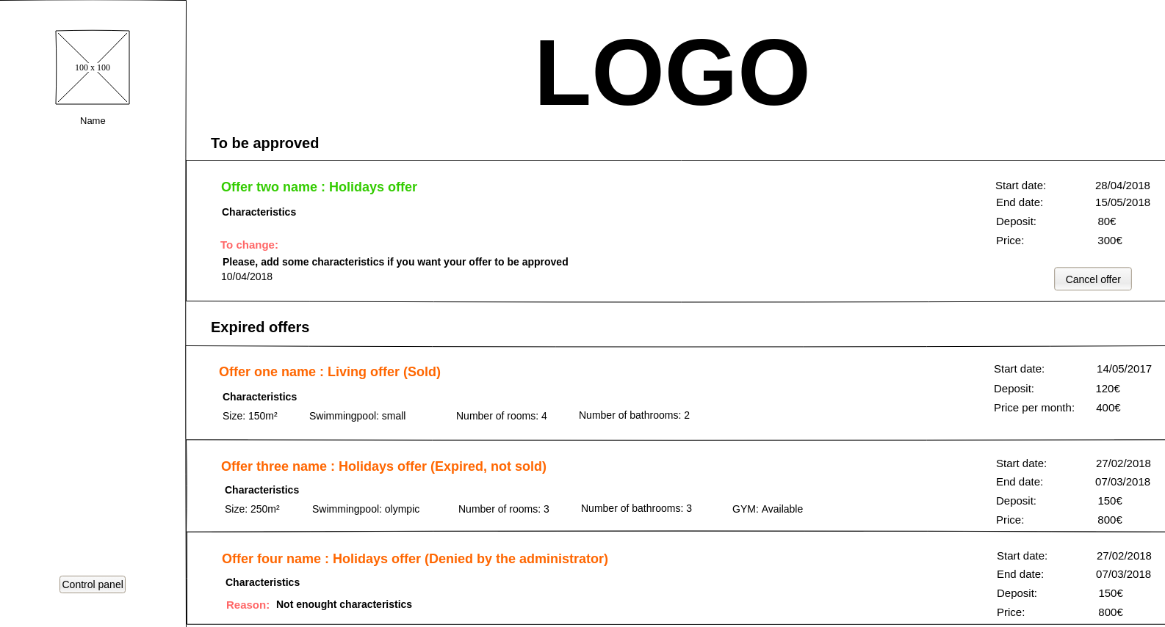
4.8 Administrator control panel
Here the system administrator can approve, deny or ask for changes the different offers. He can also unblock banned users by changing his credit card number.
